‘A1 For Dummies - Part TWO’
Converting A1
By Paul D
This Tutorial will address the the art of Converting your A1 files. You will need to learn this important step if you want a perfect runninmg track, as to get that, you will need to know how to use your Converter to change the [Rec] file inside the [ai] folder to a format that’s readable and convertable. If you have successfully managed to swap A1’s, then you may still need to adjust it a little.... Especially if the cars are still bouncing off the back straight wall…. Adjusting the A1 actually comes in Part Three, (A1 For Dummies-Adjusting A1) but you will need to learn to work with your new Converter first before you can do it, anyway….. Ooh… And you thought you would learn it, in Part Two….? Let’s do this, one step at a time….. I’m going to teach you how to convert an old game track (Leadfoot) into DTR2. Something that no one has discovered yet; or so it seems. Just like you learned in Part One, about swapping files from track to track, you will see just how easy it is, to get those old tracks working again after all these years, to enjoy all over again.... You’ll agree that having them in DTR2 is important, for the future of the game. And at the same time too, you will learn all about how to use the A1 Converter.
Okay…. Now off you go and grab that exciting program called (A1 Convert V1)….. You can visit BH Motorsports or any other site that hosts DTR2 game tool files…. Once you have the file open, take a copy of the yellow colored file, and paste it into your game [Data] inside of yourDirt Track Racing2 game folder. It should look exactly like this…..
Fig 1
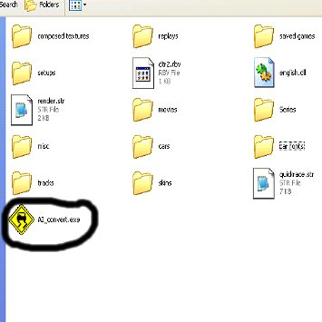

The reason is so that when converting your A1 folders from any track you have loaded up in your game, they are right next to this folder, so it saves you time searching for it. It won’t affect your game play… Trust me.
Now before we open the A1 folder, we will begin with a new exercise. Converting our Leadfoot track, into a DTR2 format so we can race against our opponents…
NB - Do not convert any DTR1, DTR-AU or DTR-Sprintcar A1’s with this program for DTR2, except only when you are Adjusting the A1 for that specific track….. (Refer to A1 For Dummies – Part Three Adjusting A1) Those games run extremely well in DTR2 so there’s no need to mess with them… You will have the cars lining up at the start line, and then once the flag drops, they will all chicken out of the race…!!! Not much good for competition, huh…. Converting to a readable file, for Adjusting the A1 points, is all you can do, for those A1’s…..
CONVERTING A LEADFOOT TRACK TO RUN IN DTR2 –
Okay… The exercise for this Tutorial is to make offroaders and buggies behave on a Leadfoot track (Offroad). Now the old tracks, simply don’t work in our game…. You won’t get the water showing up for instance, the cars chicken out; or worse luck, the track freezes on you, before you can even start the race…. But that’s another Tutorial, isn’t it…. See the Forums under Help and Support on ‘How To Fix A Bad Track’.….. Now the other game that’s yet to be converted over to DTR2 is Powerslide. The ‘Speedway’ track (PA Motorplex) works fine and maybe ‘Fox n Hound’; but the rest don’t run in DTR2 (Offline)…… To get any of these to work right, you will need the original A1’s to do the full Conversion… How do we get hold of the originals…?
EXTRACTING GAME FILES FOR DUMMIES –
If you look in your game folder, you will see some files called, [pf] [pfb] and [pfc] files… Copy them and then open up your [mods] folder which is in the same (Dirt Track Racing 2) folder. Open the [mods] folder… You will see the [ExtractPF], so paste them, right there.… Then simply take each one, and do a drag/ drop on that [ExtractPF] folder. You should then see another file open up on your screen which has a border and a black screen, and will automatically begin typing a whole lot of information insde that black box. Once you have dropped each one; open [My Computer] and then [local drive C:)] and then click on [Documnents and Settings]. Then click on [user files]. It may be the name you have given your computer. Open it and find the folder [Data]. Open that and then you should see all those lovely files from, Leadfoot… You know…. The ones you extracted only minutes ago. Once you open it, the inside of the [Data] folder should look like this….
Fig 2
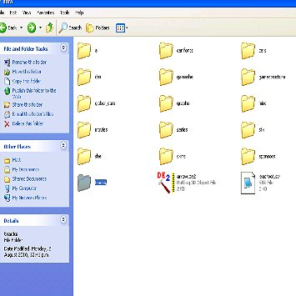
Next… Click on the highlighted folder being [tracks] and then you will see all the tracks from that game…… They should look like this…..
Fig 3
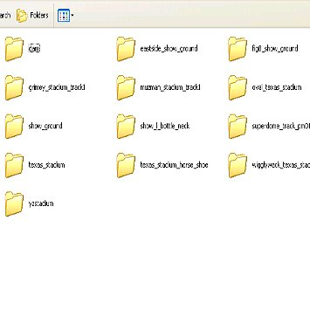
Pick out the track that you most desire for Conversion. There are two tracks in Leadfoot that take a lot more work than just converting the A1, let me tell ya’. These are [yzstadium] being Leadffoot Stadium ofcourse, and [texas_stadium_horseshoe] which is Bracken Bowl. Both of these tracks will not run without the default texture being dropped, and believe me, the latter being an anormous task. But that’s another whole tutorial, isn’t it… In this exercise we will choose [eastside_show_ground]. I will not be telling you how to convert the other files for the track so that it will run in DTR2… That’s another big tutorial…. Well not that big, really…..
- Open the [ai] and you will see the [chareasy] folder. Click on that and open it…. You will now see only two folders inside. Not much good for using without the rest of the Record folders that you would normally see in a normal [ai] folder, but they are very important, in order to get our Eastside Showground track to work… Copy the [rec] and the [select] folders. (DO NOT CUT!!!!)
- Now go to your new Leadfoot track that you have already converted to run in DTR2 that’s inside your game’s [tracks] folder. I have called mine 4 Eastside….. Open 4Eastside. I call it that simply because it’s a 4x4 track you see… But we’re all different…. Makes it easier for an old man like me, to remember what they are, you see….. Open it and then click on the [ai] folder and then the [chareasy] folder, and inside you should have the full record folders already there… If not..; this baby will never work. Right… Like in the last tutorial, rename the [rec] folder to [zzzai] as well as the [select] folder to [zzzselect]…. Now paste the copied files from Leadfoot data in there….. Simple, huh?
- Now you’re ready for the exciting bit…. Time to play with that brand-new toy… The A1 converter…… Click on it….. If you’ve already forgotten where it is, because of yet, another long and boring tutorial, then please refer to (fig 1). Click on it, and a box will appear…. Looking like this…..
Fig 4
Choose the highlighted one being Leadfoot rec file to DTR2 csv text file. That’s when the second box appears called A1 Convert… Next, you will click on the top selection of the second box being the A1 Convert, where it says…. [Select File To Load]…. And another box will then open.
Fig 5
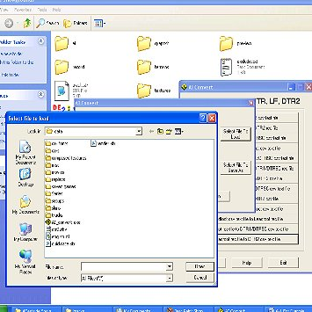
This is to select the track you’re converting….. Now…. Select [tracks] and then go and search for the track you are converting. In this case, [4Eastside] Remember it because if you select the wrong track, you may strike problems. Then select inside 4Eastside Showgrounds, the [ai] folder then click open the [chareasy] and then look for [rec] and click on that folder….
Fig 6
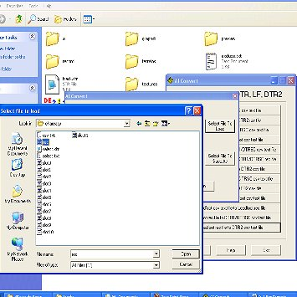
This will place the name of it in that top box of your A1 Convert…. Like this…..
Fig 7
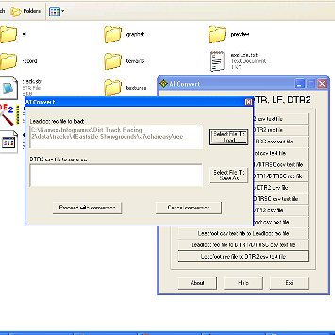
Okay…. You are nearly halway there… Stay with me….. Now click on the second box which says [Select File To Save As] and again go through the same process…;
Fig 8
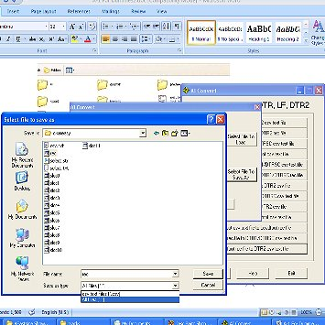
Choose in the file type (All Files) and then you should see [rec]. Select this one…. No need to create a special csv file… Trust me….. Once this is done, click on your converter where it says [Proceed With Conversion] and then save over the old Record file. Now if you have messed it up. you can always go back to your buggered old [zzai] folder can’t you and rename it back again….. To save on any mishaps, it’s always best to make a copy of the very one you are converting, alright… Just incase…. I know I should have told you that before…..!!!! But you knew that, right….????!!!! Anyway… You now have a converted file that you can read… You can open it up, in (Notepad) if you wish to read it or change anything within that folder, but for this exercise…; it’s not really necessary.
- You are now ready to convert this file to a proper DTR2 format…. Now click on the main box as shown in fig9, (DTR2 csv File to DTR2 Rec)…. It will look like this
Fig 9
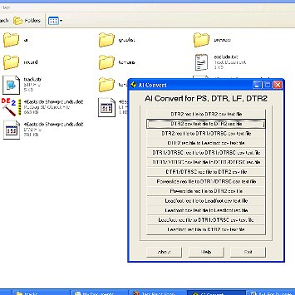
Make sure that is the selection as you have already converted from a Leadfoot to DTR2, so therefore it’s already in the DTR2 format. But ofcourse, it won’t run in your game until you convert it back to a readable file for the game itself….. Now the next step will look like this…
Fig 10
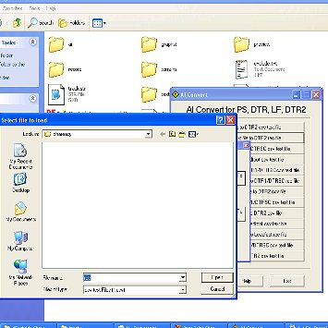
Even though it says csv files down in the lower part of the [select file to convert], simply choose [all files] and the box above should then read [rec] as this is your csv file. Do the same as before in the last half of no3 and then save, copying over the file. Now if you should get a (Runtime Errror_) it’s because you have probably selected the wrong tab eg Convert to a DTR1….. In other cases, the original [rec] file was not an original after all, but had probably been converted by someone to maybe a DTR1 etc. If you have chosen the right file to convert as I have suggested, it should save correctly and tell you that the conversion was successful…..
Now if you haven’t taken all of that in, then please ask me in the forums and I will explain any of your concerns to you as best as I can. It has never failed me, using this method…….. Maybe you could try converting a ‘Powerslide’ track… You never know.. You could be the very first to get one of them babies into the DTR2 game… If you’re fortunate enough to own a copy of that game……

I have the whole set of Leadfoot tracks converted with A1 that actually works….. They are neat fun to race on with opponents…. And you went ahead and converted the whole lot before you read to the bottom of this Tutorial, huh…?????!!!! How sad…. If you had read Part One of my Tutorial for Dummies, you would have known to copy one of my A1’s from a track that I’ve converted, and place it into the [ai] folder of your edited Leadfoot track and you’re good to go… A one minute job…. And you read all of this stupid Tutorial, just to be told that…..??!!!! No need to convert Leadfoot tracks…. But you knew that… Right.? Paul’s done the lot…. The whole game!!!!!
I will make all of these tracks and spare A1’s available to you, shortly… I just felt, you needed to learn something about Conversion first… If you get tired of waiting, then check on the Downloads/Tracks/Paul’s Tracks in Team VLR 2000 for Leadfoot tracks…. They are the only ones in existance that run in Offline for DTR2… You will be a happy, mud lickin’, and bunny hopping chappie, won’t you…..!!!!
The fundamentals of working the A1 Program is simpler than you first thought, huh…. You will need to understand this process, before moving on to Part Three of A1 For Dummies….. Adjusting A1. Good luck wuth that one…..

END OF PART TWO –
‘A1 For Dummies - Part Two’

